
End-of-Topic Project Report


STUDENT DETAILS
Name: Muhammad Ismail
Reg.no: SU-24-01-001-054
Semester/Program/Section: 3rdBS CS2
Department: CS & IT
Subject: Data Structures and Algorithms (DSA)
Date: 26-Dec-2025
Submitted to: SIR MR. NIAMAT ULLAH
PROJECT TITLE
Daily Temperature Data Logger Using 1D Arrays

ASSIGNED PROJECT DESCRIPTION:

Project Description:
This project stores, manages, and analyzes daily temperature readings using a 1D array. Users can input, display, update, search, find maximum/minimum, calculate average, and reverse temperature data through a menu-driven interface.

Objective:
- Store daily temperature readings.
- Perform operations like update, search, maximum/minimum, average, and reverse.
- Practice array handling and menu-driven programming.

Problem Statement:
Design a program that allows a user to maintain and analyze temperature data for N days using a 1D array. The program should provide a menu to perform operations such as display, update, search, find maximum/minimum, calculate average, and reverse readings.

PROGRAM SCREENSHOT:
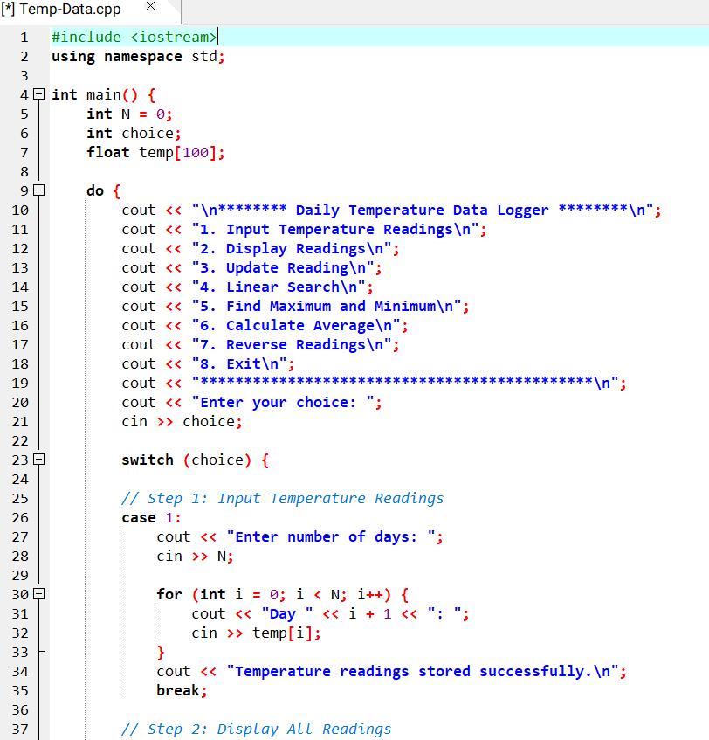
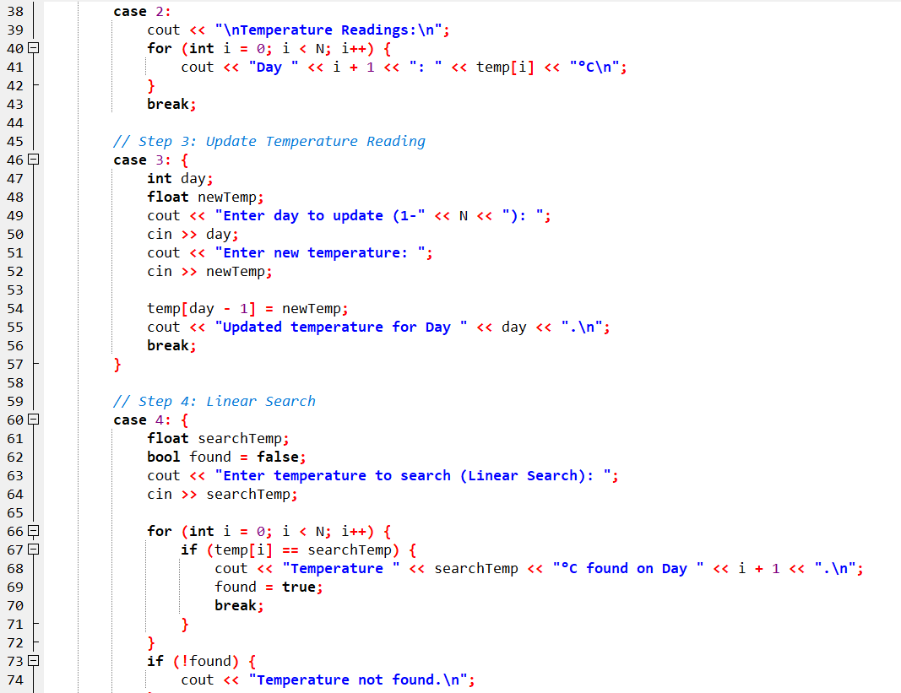
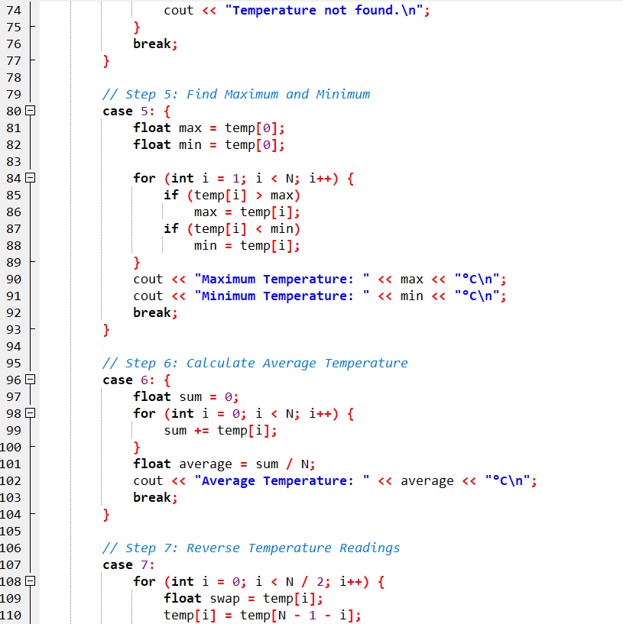
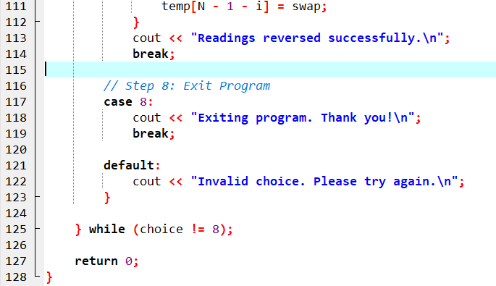
OUTPUT:
